=========================================================
SQL PRACTICE NOTES
TOPIC: DDL, DML, DCL, TCL COMMANDS
DATABASE: BANK MANAGEMENT SYSTEM
=========================================================

=========================================================
SECTION 1 : DDL (DATA DEFINITION LANGUAGE)
=========================================================

DDL COMMANDS:
1. CREATE
2. ALTER
3. DROP
4. TRUNCATE
5. RENAME
=========================================================
QUESTION 1 - CREATE TABLE
=========================================================
SCENARIO:
The bank wants to create a table to store
customer transaction details.

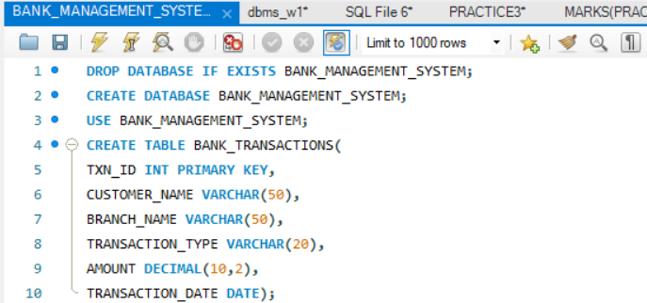

=========================================================
QUESTION 2 - ALTER TABLE ADD COLUMN
=========================================================
SCENARIO:
The bank wants to store account numbers
for every transaction.
=========================================================
QUESTION 3 - ALTER TABLE MODIFY COLUMN
=========================================================
SCENARIO:
The bank wants to increase customer name length.
=========================================================
QUESTION 4 - RENAME TABLE
=========================================================

SCENARIO:
The bank wants to rename the transaction table.
=========================================================
QUESTION 5 - TRUNCATE TABLE
=========================================================
SCENARIO:
The testing team wants to remove all records
without deleting the table structure.
=========================================================
QUESTION 6 - DROP TABLE
=========================================================
SCENARIO:
The bank no longer requires an old backup table.
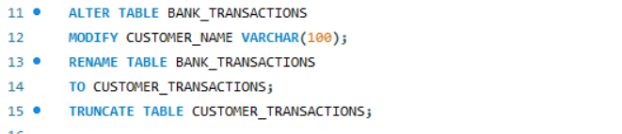
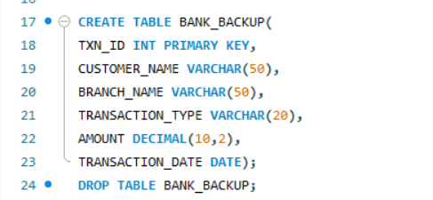
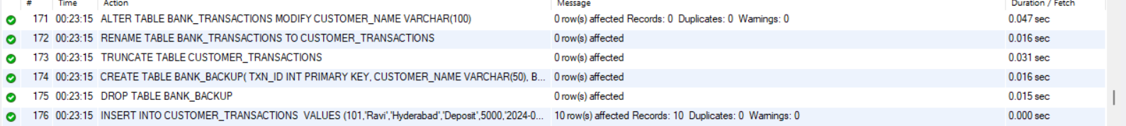

=========================================================
SECTION 2 : DML (DATA MANIPULATION LANGUAGE)
=========================================================
DML COMMANDS:
1. INSERT
2. UPDATE
3. DELETE
4. SELECT
=========================================================
STEP 1 : INSERT SAMPLE DATA
=========================================================
INSERT INTO bank_transactions VALUES
(101,'Ravi','Hyderabad','Deposit',5000,'2024-01-05'),
(102,'Sita','Hyderabad','Withdrawal',2000,'2024-01-06'),
(103,'Kiran','Vijayawada','Deposit',12000,'2024-01-08'),
(104,'Anil','Vizag','Deposit',8000,'2024-01-10'),
(105,'Priya','Hyderabad','Withdrawal',3500,'2024-01-11'),
(106,'Ramesh','Vizag','Deposit',15000,'2024-01-12'),
(107,'Keerthi','Vijayawada','Withdrawal',1000,'2024-01-13'),
(108,'Rahul','Hyderabad','Deposit',9000,'2024-01-14'),
(109,'Sneha','Vizag','Withdrawal',4000,'2024-01-15'),
(110,'Madhu','Vijayawada','Deposit',11000,'2024-01-16');
=========================================================
QUESTION 7 - INSERT
=========================================================
SCENARIO:
A new customer transaction must be recorded.

QUERY:

INSERT INTO bank_transactions
VALUES
(111,'Venu','Vizag','Deposit',7000,'2024-01-18');
OUTPUT:
1 row inserted.
=========================================================
QUESTION 8 - UPDATE
=========================================================
SCENARIO:
Customer Priya's transaction amount was entered
incorrectly and must be corrected.
QUERY:
UPDATE bank_transactions
SET amount = 5000
WHERE txn_id = 105;
OUTPUT:
1 row updated.
=========================================================
QUESTION 9 - DELETE
=========================================================
SCENARIO:
A duplicate transaction record must be removed.
QUERY:
DELETE FROM bank_transactions
WHERE txn_id = 111;
OUTPUT:
1 row deleted.

=========================================================
QUESTION 10 - SELECT
=========================================================
SCENARIO:
The branch manager wants to view all transactions.
QUERY:
SELECT *
FROM bank_transactions;
OUTPUT:
10 rows returned.
=========================================================
QUESTION 11 - SELECT WITH WHERE
=========================================================
SCENARIO:
The manager wants all deposits only.
QUERY:
SELECT *
FROM bank_transactions
WHERE transaction_type='Deposit';

OUTPUT:

6 rows returned.

=========================================================
QUESTION 12 - SELECT WITH ORDER BY
=========================================================

SCENARIO:
Management wants transactions ranked by amount.

QUERY:

SELECT *
FROM bank_transactions
ORDER BY amount DESC;

OUTPUT:

Ramesh 15000
Kiran 12000
Madhu 11000
Rahul 9000

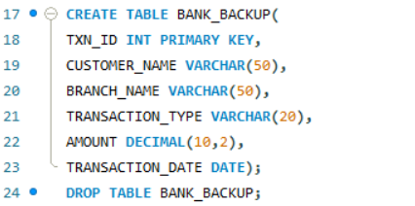
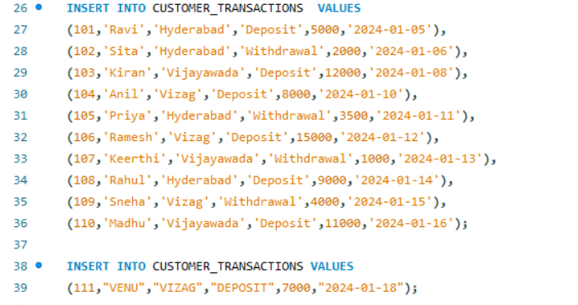
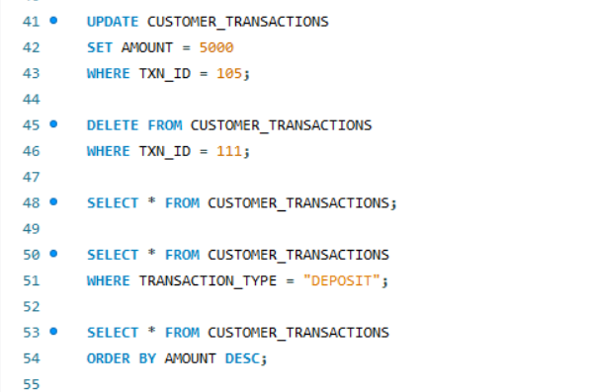
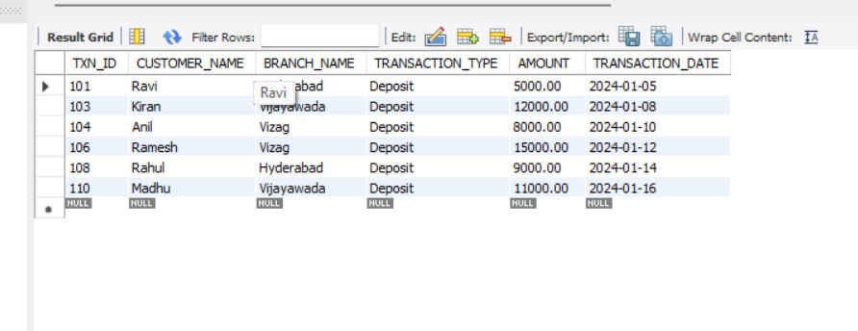
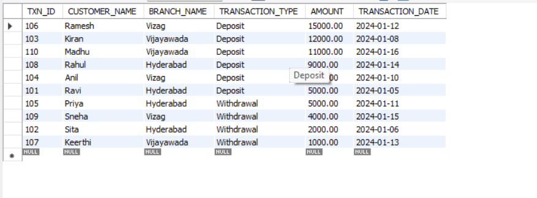
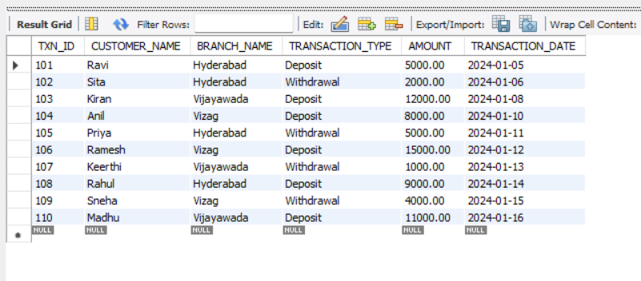

SECTION 3 : DCL (DATA CONTROL LANGUAGE)
DCL COMMANDS:
1. GRANT
2. REVOKE

QUESTION 13 - GRANT SELECT
SCENARIO:
The bank wants to allow Auditor1
to view transaction data.
QUERY:
GRANT SELECT
ON bank_transactions
TO Auditor1;
OUTPUT:
Grant succeeded.

QUESTION 14 - GRANT ALL PRIVILEGES
SCENARIO:
The DBA wants to provide complete access
to BranchManager.
QUERY:
GRANT ALL
ON bank_transactions
TO BranchManager;
OUTPUT:
Privileges granted.

QUESTION 15 - REVOKE SELECT
SCENARIO:
Auditor1 no longer requires access.
QUERY:
REVOKE SELECT
ON bank_transactions
FROM Auditor1;
OUTPUT:
Privilege revoked.

QUESTION 16 - REVOKE ALL
SCENARIO:
Temporary access granted to a user
must now be removed.
QUERY:
REVOKE ALL
ON bank_transactions
FROM BranchManager;
OUTPUT:
Privileges revoked.

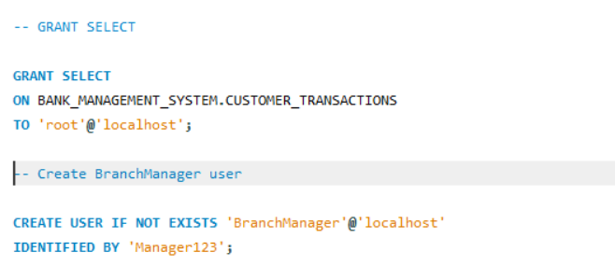
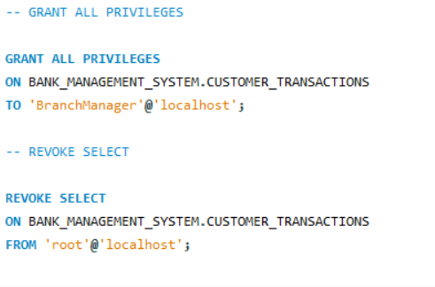
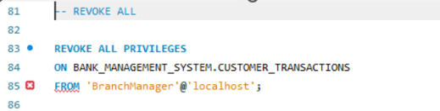

SECTION 4 : TCL (TRANSACTION CONTROL LANGUAGE)

TCL COMMANDS:
1. COMMIT
2. SAVEPOINT
3. ROLLBACK

QUESTION 17 - COMMIT
SCENARIO:
After updating multiple transactions,
the manager wants to permanently save changes.
QUERY:
UPDATE bank_transactions
SET amount=6000
WHERE txn_id=101;
COMMIT;
OUTPUT:
Transaction committed successfully.

QUESTION 18 - SAVEPOINT
SCENARIO:
The bank wants a recovery point before
making bulk updates.
QUERY:
SAVEPOINT Before_Update;
OUTPUT:
Savepoint created.

QUESTION 19 - ROLLBACK TO SAVEPOINT
SCENARIO:
An incorrect update was performed and
must be reversed.
QUERY:
UPDATE bank_transactions
SET amount=99999
WHERE txn_id=102;
ROLLBACK TO Before_Update;
OUTPUT:
Changes rolled back to savepoint.

QUESTION 20 - FULL TCL EXAMPLE
SCENARIO:
The bank processes multiple updates and
wants the option to undo some of them.
QUERY:
UPDATE bank_transactions
SET amount=7000
WHERE txn_id=101;
SAVEPOINT SP1;
UPDATE bank_transactions
SET amount=9000
WHERE txn_id=102;
ROLLBACK TO SP1;
COMMIT;
OUTPUT:
Transaction 101 updated and saved.
Transaction 102 restored to previous value.

